C PROGRAMMING
NAME : YOKITHA SS
ROLL NO : 241801327
WEEK :11
TOPIC : STRING HANDLING FUNCTION

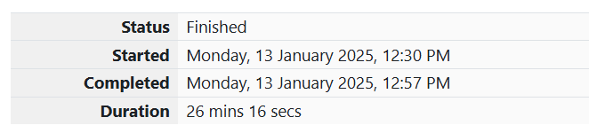Problem Statement: Alice and Strings
Two strings AAA and BBB comprising lower-case English letters are compatible if they are equal or can be made equal by following this step any number of times:
- Select a prefix from the string AAA (possibly empty) and increase the alphabetical value of all the characters in the prefix by the same valid amount. For example, if the string is xyz and we select the prefix xy, then we can convert it to yx by increasing the alphabetical value by 1. However, if we select the prefix xyz, we cannot increase the alphabetical value.
Your task is to determine if the given strings AAA and BBB are compatible.
Input Format
- First line: String AAA
- Second line: String BBB
Output Format
- For each test case, print "YES" if string AAA can be converted to string BBB, otherwise print "NO".
Constraints
- 1≤len(A)≤1,000,0001 \leq \text{len}(A) \leq 1,000,0001≤len(A)≤1,000,000
- 1≤len(B)≤1,000,0001 \leq \text{len}(B) \leq 1,000,0001≤len(B)≤1,000,000
Sample Input
Copy code
abaca
cdbda
Sample Output
objectivec
Copy code
YES

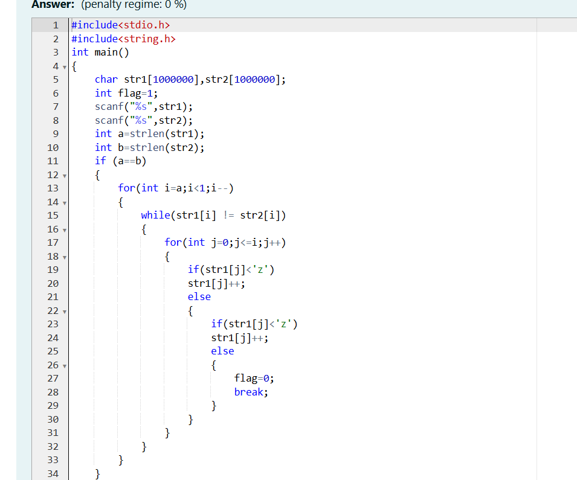
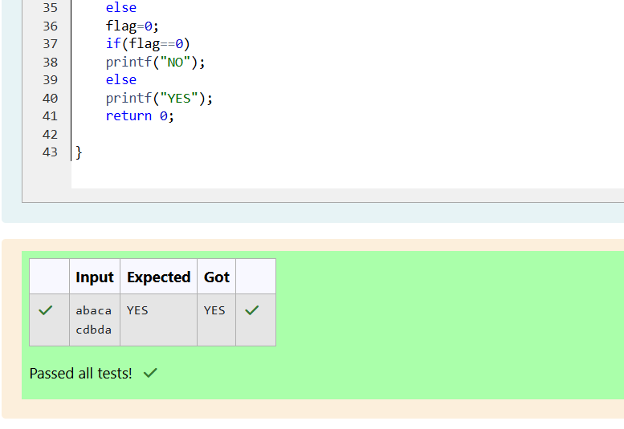
2.

Problem Statement: Password
Danny has a possible list of passwords for Manny's Facebook account. All passwords have an odd length. Danny knows that Manny is a big fan of palindromes, so his password and the reverse of his password should both be in the list.
You have to print the length of Manny's password and its middle character.
Note: The solution will be unique.
Input Format
- The first line contains an integer NNN, the number of possible passwords.
- Each of the following NNN lines contains a single word, its length being an odd number greater than 2 and less than 14. All characters are lowercase letters of the English alphabet.
Output Format
- Print the length of the correct password and its central letter.
Constraints
- 1≤N≤1001 \leq N \leq 1001≤N≤100
Sample Input
python
Copy code
4
abc
def
feg
cba
Sample Output
css
Copy code
3 b

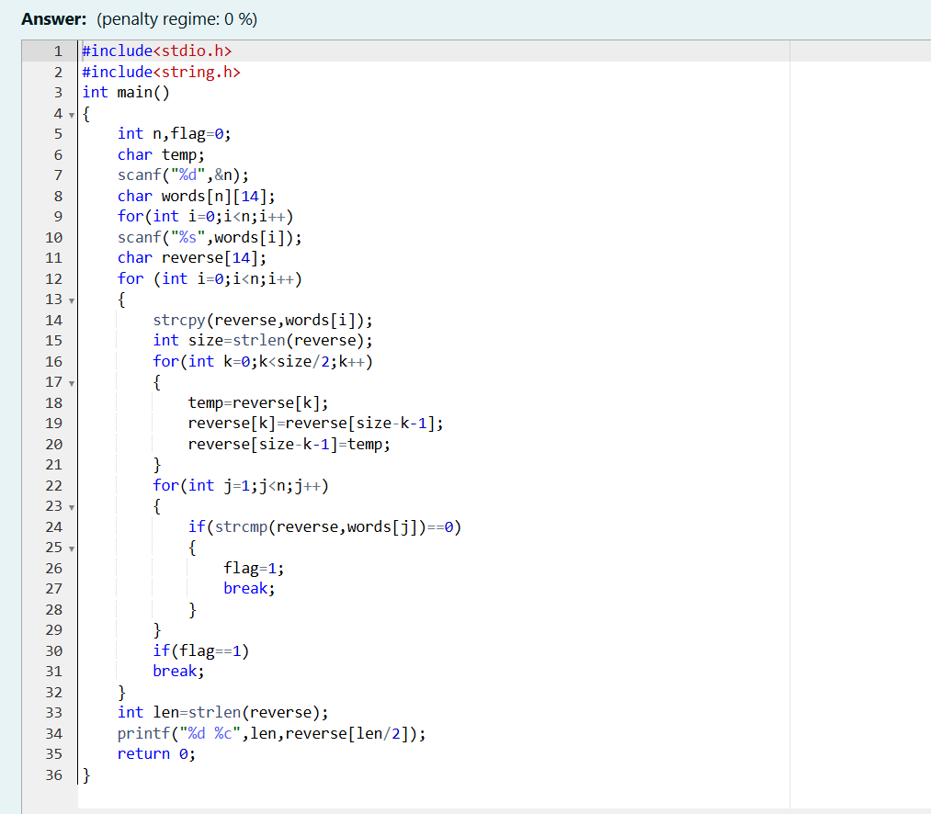
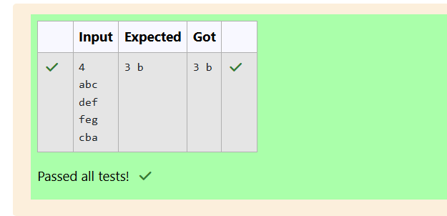

3. Problem Statement: Pizza Confusion
Joey loves to eat pizza. But he is worried because the quality of pizza made by most of the restaurants is deteriorating. The last few pizzas ordered by him did not taste good :(. Joey is feeling extremely hungry and wants to eat pizza. But he is confused about which restaurant to order from. As always, he asks Chandler for help.
Chandler suggests that Joey should give each restaurant some points and then choose the restaurant with the maximum points. If more than one restaurant has the same points, Joey can choose the one with the lexicographically smallest name.
Joey has assigned points to all the restaurants but can't figure out which restaurant satisfies Chandler's criteria. Can you help him out?
Input Format
- First line: NNN, the total number of restaurants
- Next NNN lines: Name of the restaurant and points awarded by Joey, separated by a space
  - Restaurant name has no spaces, consists of lowercase letters, and will not exceed 20 characters.
Output Format
- Print the name of the restaurant that Joey should choose.
Constraints
- 1≤N≤1051 \leq N \leq 10^51≤N≤105
- 1≤Points≤1061 \leq \text{Points} \leq 10^61≤Points≤106
Sample Input
Copy code
3
Pizzeria 108
Dominos 145
Pizzapizza 49
Sample Output
Copy code
Dominos

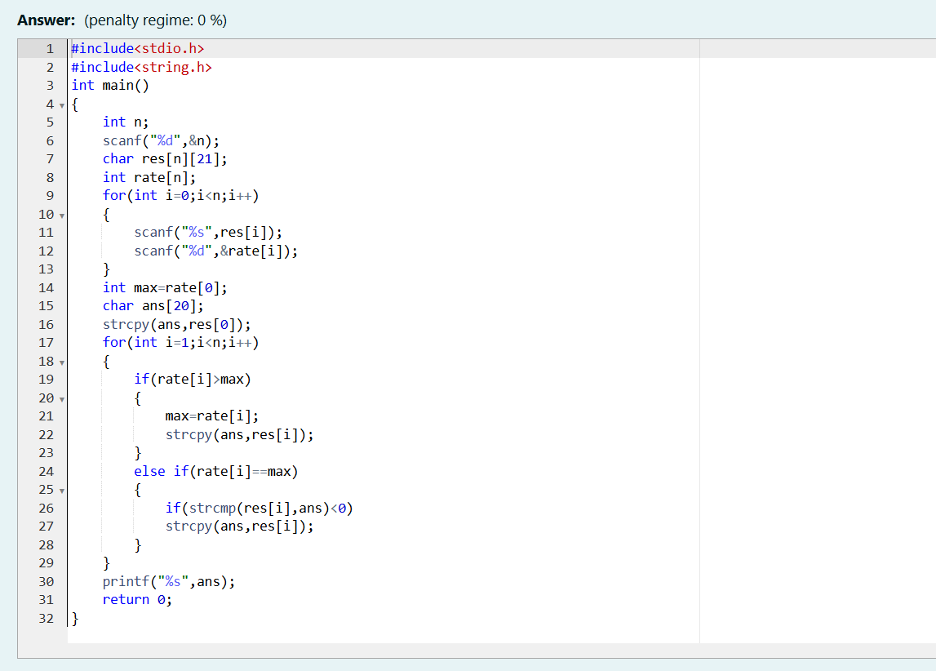
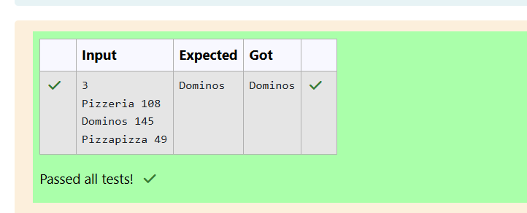

Problem Statement: What is Your Mobile Number?
Problem Statement
These days, Bechan Chacha is depressed because his crush gave him a list of mobile numbers, some of which are valid and some are not. Bechan Chacha has a special power that he can pick his crush’s number only if he has a valid set of mobile numbers. Help him determine the valid numbers.
You are given a string S, and you have to determine whether it is a valid mobile number or not. A mobile number is valid only if it is of length 10, consists of numeric values, and shouldn’t have prefix zeroes.
Input Format
The first line of input contains T, representing the total number of test cases.
Next T lines each contain S, as described in the problem statement.
Output Format
Print "YES" if it is a valid mobile number; otherwise, print "NO". (Quotes are for clarity.)
Constraints
1 ≤ T ≤ 10³
Sum of string lengths ≤ 10⁵
Sample Input
Copy code
3
1234567890
0123456789
0123456.87
Sample Output
objectivec
Copy code
YES
NO
NO

